- ATM Transaction Sequence Simulation: Process a sequence of deposits and withdrawals, maintain a simulated balance, enforce withdrawal limits, reject invalid transactions, and produce a transaction summary.
Problem Statement
Process a sequence of ATM transactions:
- Accept deposits and withdrawals.
- Maintain account balance.
- Enforce a withdrawal limit of ₹10,000 per transaction.
- Reject invalid transactions.
- Display transaction summary.

Computational Thinking
1. Decomposition
Break the problem into:
- Read transactions
- Validate transactions
- Update balance
- Store history
- Generate summary
2. Pattern Recognition
Every transaction contains:
- Transaction type (Deposit/Withdraw)
- Amount
3. Abstraction
Represent transactions as tuples:
Plain Text
("D", 5000)
("W", 2000)
4. Algorithm Design
Process each transaction one by one using a loop.
Algorithm
- Set initial balance = 10000.
- Create a list of transactions.
- For each transaction:
  - If deposit:
    - Add amount to balance.
  - If withdrawal:
    - Check withdrawal limit.
    - Check sufficient balance.
    - Deduct amount.
  - Otherwise reject transaction.
- Count successful deposits and withdrawals.
- Display final balance and summary.
Flowchart
┌───────┐
│ Start │
└───┬───┘
│
▼
Initialize Balance
│
▼
Read Transaction
│
▼
Transaction Type?
┌────┴────┐
│ │
▼ ▼
Deposit Withdraw
│ │
▼ ▼
Add Limit Check
Amount │
│ ▼
│ Balance Check
│ │
▼ ▼
Update Update
Balance Balance
│ │
└─────┬──────┘
▼
More Transactions?
Yes ──► Repeat
│
No
▼
Print Summary
│
▼
End
Pseudocode
BEGIN
balance ← 10000
FOR each transaction
IF type = "D"
balance ← balance + amount
ELSE IF type = "W"
IF amount > 10000
Print "Limit Exceeded"
ELSE IF amount > balance
Print "Insufficient Balance"
ELSE
balance ← balance - amount
ELSE
Print "Invalid Transaction"
END FOR
Print balance
Print summary
END
Variables and Data Types
Variable | Data Type | Purpose
balance | Integer | Account balance
amount | Integer | Transaction amount
trans_type | String | D or W
transactions | List | Stores all transactions
summary | Tuple | Summary data

Python Program
# Initial balance
balance = 10000
# Transactions stored as tuples
transactions = [
("D", 5000),
("W", 3000),
("W", 12000),
("W", 15000),
("D", 2000),
("X", 1000)
]
deposit_count = 0
withdraw_count = 0
invalid_count = 0
history = []
for trans_type, amount in transactions: # tuple unpacking
if trans_type == "D":
balance += amount
deposit_count += 1
history.append(("Deposit", amount))
elif trans_type == "W":
if amount > 10000:
print("Rejected:", amount,
"- Withdrawal limit exceeded")
invalid_count += 1
elif amount > balance:
print("Rejected:", amount,
"- Insufficient balance")
invalid_count += 1
else:
balance -= amount
withdraw_count += 1
history.append(("Withdraw", amount))
else:
print("Invalid Transaction Type")
invalid_count += 1
print("\nTransaction History")
for item in history:
print(item)
summary = (
deposit_count,
withdraw_count,
invalid_count,
balance
)
print("\nSummary")
print("Deposits:", summary[0])
print("Withdrawals:", summary[1])
print("Invalid:", summary[2])
print("Final Balance:", summary[3])
Sample Output

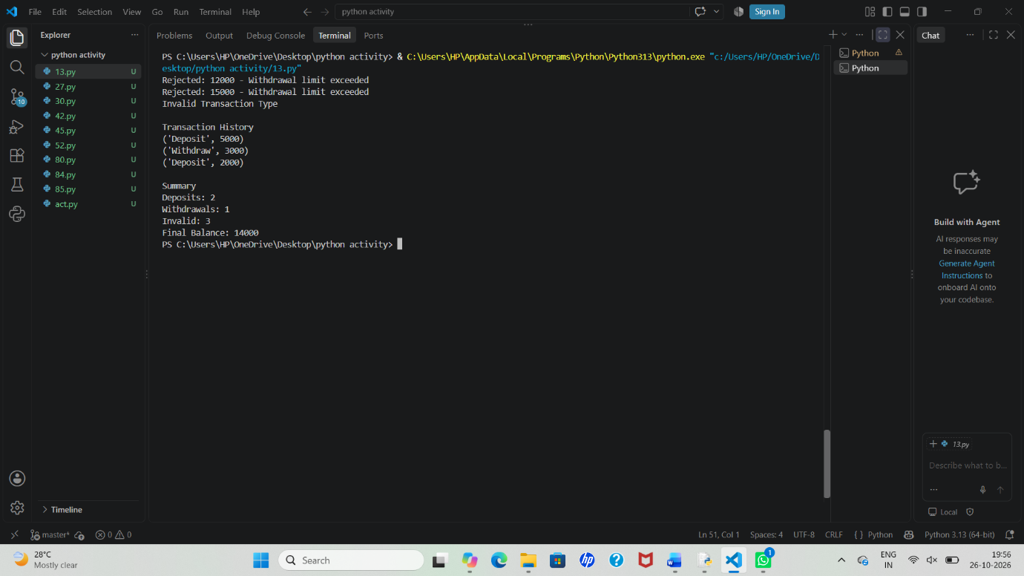
- Multi-Currency Travel Budget Analysis: Convert travel expenses using supplied exchange rates, incorporate conversion fees, compare planned spending against a budget, and identify the largest expense category.

Problem Statement
A traveler incurs expenses in different currencies. Convert all expenses into a home currency (INR) using given exchange rates, add conversion fees, compare total spending with the planned budget, and identify the largest expense category.
Computational Thinking
1. Decomposition
Break the problem into:
- Store expenses
- Convert currencies
- Add conversion fees
- Calculate total spending
- Compare with budget
- Find largest expense category
2. Pattern Recognition
Each expense contains:
- Category
- Amount
- Currency
3. Abstraction
Represent each expense as a tuple:
Plain Text
("Hotel", 200, "USD")
("Food", 150, "EUR")
("Transport", 10000, "JPY")
4. Algorithm Design
Process every expense using a loop and keep track of totals.

Algorithm
- Input travel budget.
- Store exchange rates.
- Store expenses in a list of tuples.
- For each expense:
  - Convert amount to INR.
  - Add conversion fee.
  - Add to total spending.
- Compare total spending with budget.
- Find the expense category with the highest cost.
- Display summary.

Flowchart
┌───────┐
│ Start │
└───┬───┘
│
▼
Input Budget
│
▼
Read Expense
│
▼
Get Exchange Rate
│
▼
Convert Currency
│
▼
Add Conversion Fee
│
▼
Add to Total
│
▼
More Expenses?
Yes ──► Repeat
│
No
▼
Find Largest Expense
│
▼
Compare Budget
│
▼
Display Summary
│
▼
End
Pseudocode
BEGIN
budget ← 50000
total ← 0
FOR each expense
converted ← amount × exchange_rate
fee ← converted × 0.02
final_cost ← converted + fee
total ← total + final_cost
END FOR
Find maximum expense
IF total > budget
Print "Budget Exceeded"
ELSE
Print "Within Budget"
END IF
Print summary
END
Variables and Data Types
Variable | Data Type | Purpose
budget | Float | Planned budget
total | Float | Total spending
amount | Float | Expense amount
category | String | Expense category
currency | String | Currency code
rates | Dictionary | Exchange rates
expenses | List | Expense records
summary | Tuple | Report data
Python Program
# Travel Budget
budget = 50000
# Exchange Rates (to INR)
rates = {
"USD": 83,
"EUR": 90,
"JPY": 0.56
}
# Expenses stored as tuples
expenses = [
("Hotel", 200, "USD"),
("Food", 150, "EUR"),
("Transport", 10000, "JPY"),
("Shopping", 100, "USD")
]
conversion_fee_rate = 0.02 # 2%
total_spending = 0
largest_category = ""
largest_amount = 0
expense_report = []
for category, amount, currency in expenses: # tuple unpacking
converted = amount * rates[currency]
fee = converted * conversion_fee_rate
final_cost = converted + fee
total_spending += final_cost
expense_report.append(
[category, currency, amount, round(final_cost, 2)]
)
if final_cost > largest_amount:
largest_amount = final_cost
largest_category = category
print("Expense Details")
for item in expense_report:
print(item)
print("\nTotal Spending:", round(total_spending, 2))
if total_spending > budget:
print("Status: Budget Exceeded")
print("Exceeded By:",
round(total_spending - budget, 2))
else:
print("Status: Within Budget")
print("Remaining Budget:",
round(budget - total_spending, 2))
summary = (
round(total_spending, 2),
largest_category,
round(largest_amount, 2)
)
print("\nSummary")
print("Total Spending:", summary[0])
print("Largest Category:", summary[1])
print("Largest Expense:", summary[2])
Sample Output
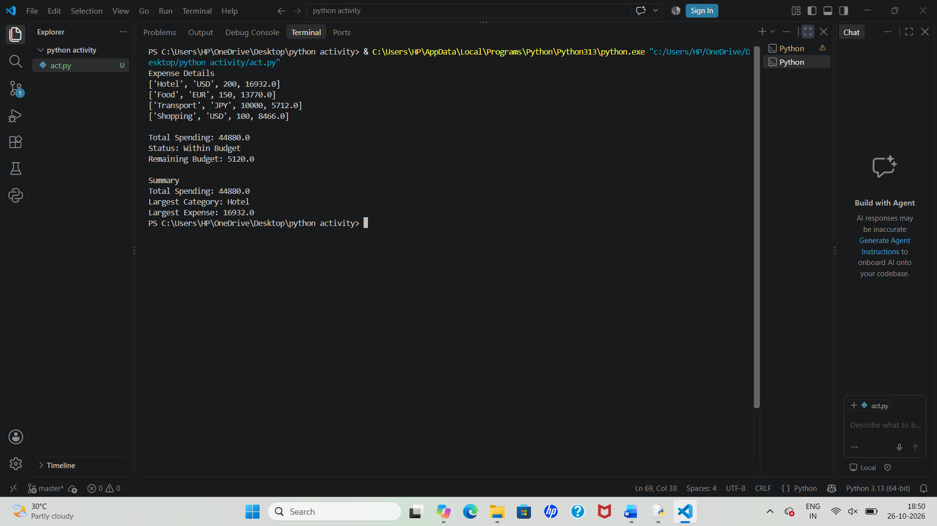
30. Student Email and Identifier Validation: Validate student email-like strings and registration identifiers against supplied formatting rules, reporting malformed separators, invalid character groups, and missing components.
Problem Statement
Validate student email-like strings and registration identifiers according to given formatting rules and report:
- Missing components
- Malformed separators
- Invalid character groups
- Incorrect identifier format
Computational Thinking
1. Decomposition
Break the problem into smaller tasks:
- Validate email format
- Validate registration ID format
- Check separators
- Check character groups
- Generate validation report
2. Pattern Recognition
Valid Email Pattern:
Plain Text
studentname@college.edu
Requirements:
- One @
- One .
- Username before @
- Domain between @ and .
- Extension after .
Valid Registration ID Pattern:
Plain Text
CSE-2025-101
Requirements:
- Department Code (letters)
- Year (4 digits)
- Roll Number (3 digits)
- Separated by hyphens -

3. Abstraction
Represent records as tuples:
Plain Text
("john123@college.edu", "CSE-2025-101")
("mary@college", "ECE2025102")

4. Algorithm Design
Process each student record one by one and validate both fields.

Algorithm
- Store student records.
- For each record:
  - Validate email.
  - Validate registration ID.
- Report errors if found.
- Save valid records.
- Display summary.
Flow Chart
┌───────┐
│ Start │
└───┬───┘
│
▼
Read Student Record
│
▼
Validate Email
│
▼
Email Valid?
┌───┴───┐
│ │
No Yes
│ │
Error ▼
│ Validate ID
│ │
▼ ▼
Report ID Valid?
Error ┌──┴──┐
│ │
No Yes
│ │
Report Store
Error Record
│
▼
More Records?
Yes ───► Repeat
│
No
▼
Print Summary
│
▼
End
Variables and Data Types
Variable | Data Type | Purpose
email | String | Student email
reg_id | String | Registration ID
records | List | Student records
errors | List | Validation errors
valid_count | Integer | Number of valid records
summary | Tuple | Final statistics
Python Program
# Student Records
records = [
("john123@college.edu", "CSE-2025-101"),
("mary@college", "ECE2025-102"),
("alex@@college.edu", "IT-202-103"),
("sara.college.edu", "MECH-2025-104"),
("rohit@college.edu", "EEE-2025-105")
]
valid_records = []
errors = []
for email, reg_id in records: # tuple unpacking
email_valid = True
reg_valid = True
# ------------------
# Email Validation
# ------------------
if email.count("@") != 1:
email_valid = False
errors.append([email, "Malformed separator '@'"])
elif "." not in email.split("@")[1]:
email_valid = False
errors.append([email, "Missing domain extension"])
else:
username, domain = email.split("@")
if username == "":
email_valid = False
errors.append([email, "Missing username"])
# ------------------
# Registration ID Validation
# ------------------
parts = reg_id.split("-")
if len(parts) != 3:
reg_valid = False
errors.append([reg_id, "Malformed separator '-'"])
else:
dept, year, roll = parts
if not dept.isalpha():
reg_valid = False
errors.append([reg_id, "Invalid department code"])
if not (year.isdigit() and len(year) == 4):
reg_valid = False
errors.append([reg_id, "Invalid year group"])
if not (roll.isdigit() and len(roll) == 3):
reg_valid = False
errors.append([reg_id, "Invalid roll number"])
# ------------------
# Store Valid Records
# ------------------
if email_valid and reg_valid:
valid_records.append((email, reg_id))
# ------------------
# Summary
# ------------------
summary = (
len(records),
len(valid_records),
len(errors)
)
# ------------------
# Output
# ------------------
print("VALID RECORDS")
for item in valid_records:
print(item)
print("\nERROR REPORT")
for error in errors:
print(error)
print("\nSUMMARY")
print("Total Records :", summary[0])
print("Valid Records :", summary[1])
print("Errors Found :", summary[2])

Sample Output
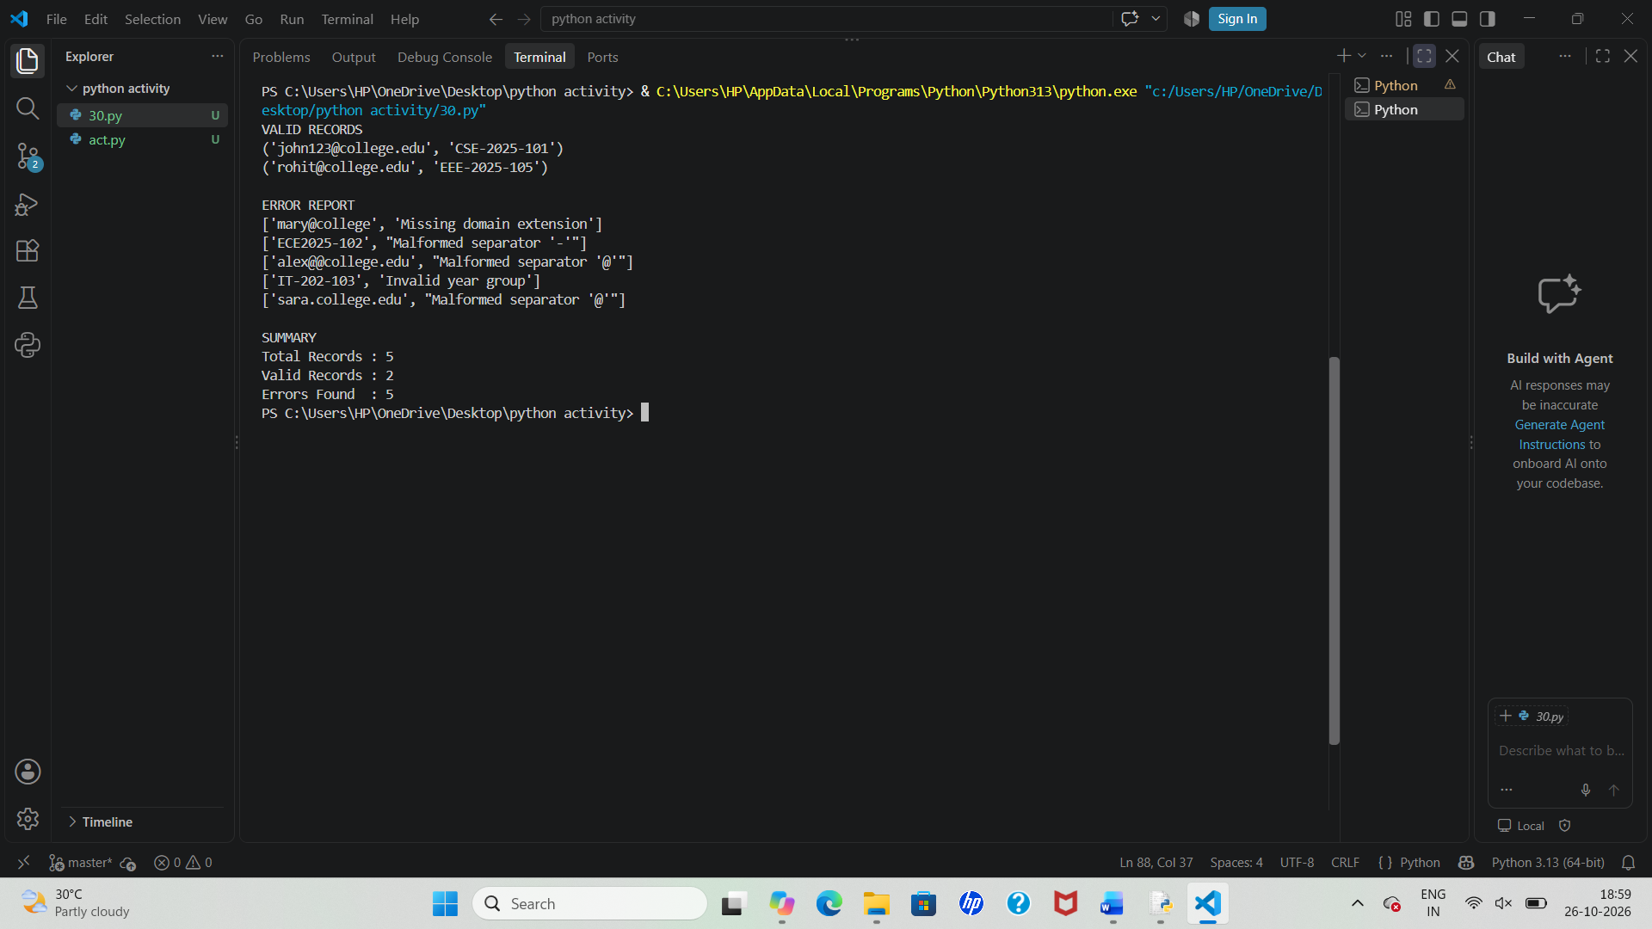
45. Weekly Electricity Consumption Matrix: Process appliance-wise electricity readings across seven days, calculate daily and appliance totals, and identify consumption exceeding specified limits.
Problem Statement
Process appliance-wise electricity consumption readings for 7 days, calculate:
- Daily total consumption
- Appliance-wise total consumption
- Overall consumption
- Appliances exceeding specified limits
- Days exceeding daily limits
Computational Thinking
1. Decomposition
Break the problem into smaller parts:
- Store appliance readings
- Calculate appliance totals
- Calculate daily totals
- Compare against limits
- Generate reports

2. Pattern Recognition
Each appliance has 7 daily readings:
Plain Text
Fan → 1 2 1 2 1 2 1
AC → 8 7 9 8 9 10 8
Fridge → 3 3 3 3 3 3 3
The same calculations repeat for every appliance.

3. Abstraction
Represent data using a matrix (nested list):
Plain Text
[
[1,2,1,2,1,2,1], ← Fan
[8,7,9,8,9,10,8], ← AC
[3,3,3,3,3,3,3] ← Fridge
]

4. Algorithm Design
Use loops to calculate:
- Row totals → Appliance totals
- Column totals → Daily totals
- Maximum consumption
- Limit violations

Algorithm
- Store appliance names and weekly readings.
- For each appliance:
  - Compute weekly total.
  - Check limit.
- For each day:
  - Compute total consumption.
  - Check daily limit.
- Determine highest consuming appliance.
- Display summary.

Flowchart
┌───────┐
│ Start │
└───┬───┘
│
▼
Read Appliance Matrix
│
▼
Calculate Appliance Totals
│
▼
Check Appliance Limits
│
▼
Calculate Daily Totals
│
▼
Check Daily Limits
│
▼
Find Highest Consumption
│
▼
Display Report
│
▼
End
Pseudocode
BEGIN
FOR each appliance
appliance_total ← SUM(readings)
IF appliance_total > limit
Report exceed
END FOR
FOR each day
daily_total ← sum of all appliances
IF daily_total > day_limit
Report exceed
END FOR
Find appliance with maximum total
Display results
END
Variables and Data Types
Variable | Data Type | Purpose
appliances | List | Appliance names
readings | Nested List | Weekly consumption
total | Integer | Total units
day_total | Integer | Daily units
limit | Integer | Allowed limit
highest | Tuple | Maximum consumption data
appliance | String | Appliance name
Python Program
# Appliance Names
appliances = ["Fan", "AC", "Fridge", "Washing Machine"]
# Weekly Consumption Matrix (7 Days)
readings = [
[1, 2, 1, 2, 1, 2, 1],
[8, 7, 9, 8, 9, 10, 8],
[3, 3, 3, 3, 3, 3, 3],
[2, 1, 2, 1, 2, 1, 2]
]
appliance_limit = 40
daily_limit = 15
appliance_totals = []
daily_totals = [0] * 7
highest_appliance = ""
highest_consumption = 0
print("APPLIANCE TOTALS")
for appliance, week_data in zip(appliances, readings):
total = sum(week_data)
appliance_totals.append(total)
print(appliance, "=", total, "units")
if total > appliance_limit:
print(" Limit Exceeded!")
if total > highest_consumption:
highest_consumption = total
highest_appliance = appliance
# Daily Totals
print("\nDAILY TOTALS")
for day in range(7):
total = 0
for appliance in readings:
total += appliance[day]
daily_totals[day] = total
print("Day", day + 1, "=", total, "units")
if total > daily_limit:
print(" Daily Limit Exceeded!")
# Tuple Summary
summary = (
highest_appliance,
highest_consumption,
sum(appliance_totals)
)
# Tuple Unpacking
name, consumption, overall = summary
print("\nSUMMARY")
print("Highest Appliance :", name)
print("Consumption :", consumption, "units")
print("Overall Usage :", overall, "units")
Sample Output
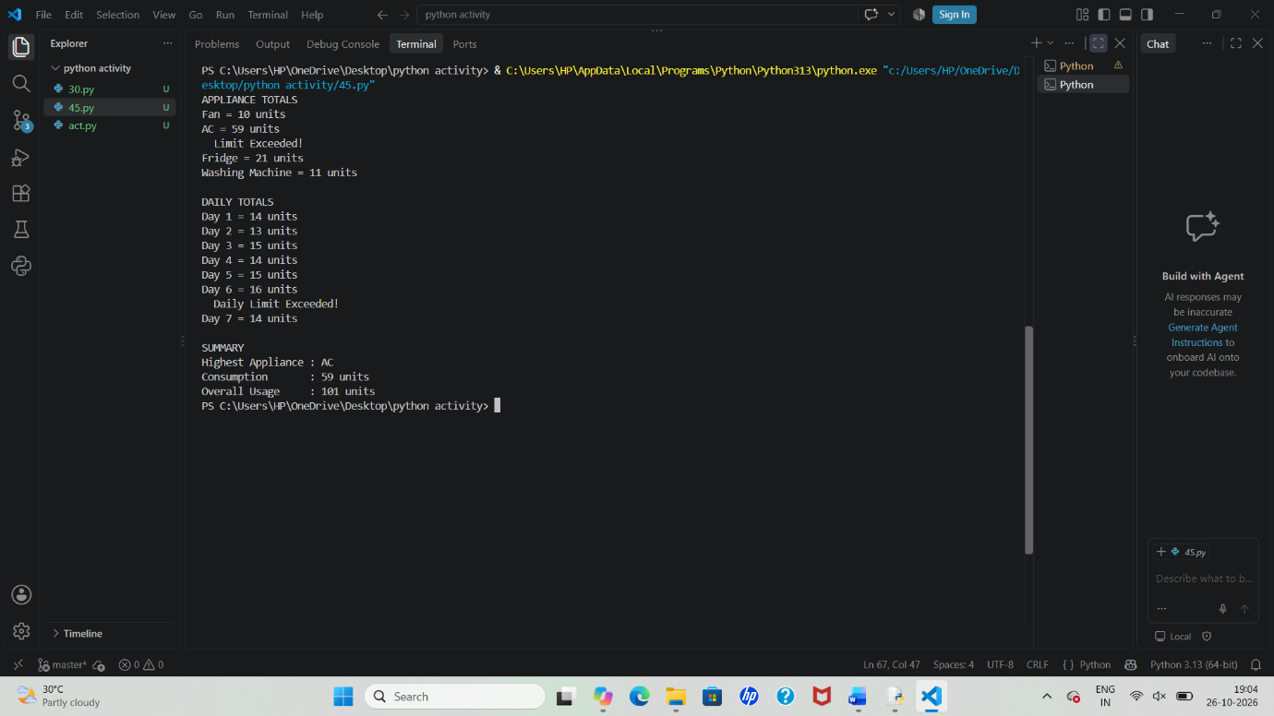
Pattern Generation
Display a simple electricity usage pattern:
Python Program
for i in range(1, 6):
print("⚡" * i)
Output:
Plain Text
⚡
⚡⚡
⚡⚡⚡
⚡⚡⚡⚡
⚡⚡⚡⚡⚡
52. Hackathon Team Formation and Ranking: Analyse student scores and team compositions, validate team sizes, aggregate round-wise scores, and resolve tied rankings using predefined rules.
Problem Statement
Analyze student scores and team compositions in a hackathon:
- Validate team sizes.
- Aggregate round-wise scores.
- Calculate team total scores.
- Rank teams.
- Resolve tied rankings using predefined rules.
- Generate a final leaderboard.
Computational Thinking
1. Decomposition
Split the problem into:
- Validate teams
- Calculate scores
- Aggregate round results
- Detect ties
- Rank teams
- Display leaderboard

2. Pattern Recognition
Each team has:
Plain Text
Team Name
Members
Round 1 Score
Round 2 Score
Round 3 Score
Example:
Plain Text
Alpha
Members = 3
Scores = [85, 90, 95]

3. Abstraction
Represent teams using tuples:
Plain Text
("Alpha", ["Asha", "Rahul", "Kiran"], [85,90,95])

4. Algorithm Design
Process each team:
- Check member count.
- Sum all round scores.
- Store results.
- Sort with tie-breaking rules.
- Assign ranks.

Algorithm
- Store team information.
- Define minimum and maximum team size.
- For each team:
  - Validate size.
  - Calculate total score.
- Sort teams according to ranking rules.
- Assign ranks.
- Display final leaderboard.

Flowchart
┌───────┐
│ Start │
└───┬───┘
│
▼
Read Team Data
│
▼
Validate Team Size
│
┌───┴───┐
│Valid? │
└───┬───┘
│Yes
▼
Calculate Total
│
▼
Store Result
│
▼
More Teams?
Yes ──► Repeat
│
No
▼
Sort Teams
│
▼
Resolve Ties
│
▼
Assign Ranks
│
▼
Display Leaderboard
│
▼
End
Psuedocode
BEGIN
FOR each team
member_count ← size(team)
IF member_count invalid
Report Error
ELSE
total ← sum(round scores)
Store total
END FOR
Sort teams by:
Total Score DESC
Final Round DESC
Team Name ASC
Assign ranks
Display leaderboard
END
Variables and Data Types
Variable | Data Type | Purpose
teams | List | Team information
members | List | Team members
scores | List | Round scores
total | Integer | Team total
rank | Integer | Team rank
team_name | String | Team name
result | Tuple | Team summary
Python Program
# Team Data
teams = [
("Alpha",
["Asha", "Rahul", "Kiran"],
[85, 90, 95]),
("Beta",
["Arun", "Divya", "Nisha"],
[88, 92, 90]),
("Gamma",
["Sai", "Ravi"],
[90, 90, 90]),
("Delta",
["Anu", "Rohit", "Vikas"],
[85, 90, 95])
]
MIN_TEAM_SIZE = 3
MAX_TEAM_SIZE = 5
valid_teams = []
invalid_teams = []
# Team Validation
for team_name, members, scores in teams: # tuple unpacking
member_count = len(members)
if member_count < MIN_TEAM_SIZE \
or member_count > MAX_TEAM_SIZE:
invalid_teams.append(
(team_name, "Invalid Team Size")
)
else:
total_score = sum(scores)
valid_teams.append(
(
team_name,
total_score,
scores[-1], # final round score
member_count
)
)
# Ranking with Tie Rules
ranked_teams = sorted(
valid_teams,
key=lambda x: (-x[1], -x[2], x[0])
)
print("LEADERBOARD")
print("-" * 40)
rank = 1
for team_name, total, final_round, size in ranked_teams:
print(
f"{rank}. {team_name}"
f" | Total={total}"
f" | Final Round={final_round}"
f" | Members={size}"
)
rank += 1
print("\nINVALID TEAMS")
for team in invalid_teams:
print(team)
# Summary Tuple
summary = (
len(teams),
len(valid_teams),
len(invalid_teams)
)
# Tuple Unpacking
total_teams, valid_count, invalid_count = summary
print("\nSUMMARY")
print("Total Teams :", total_teams)
print("Valid Teams :", valid_count)
print("Invalid Teams :", invalid_count)
Sample Output
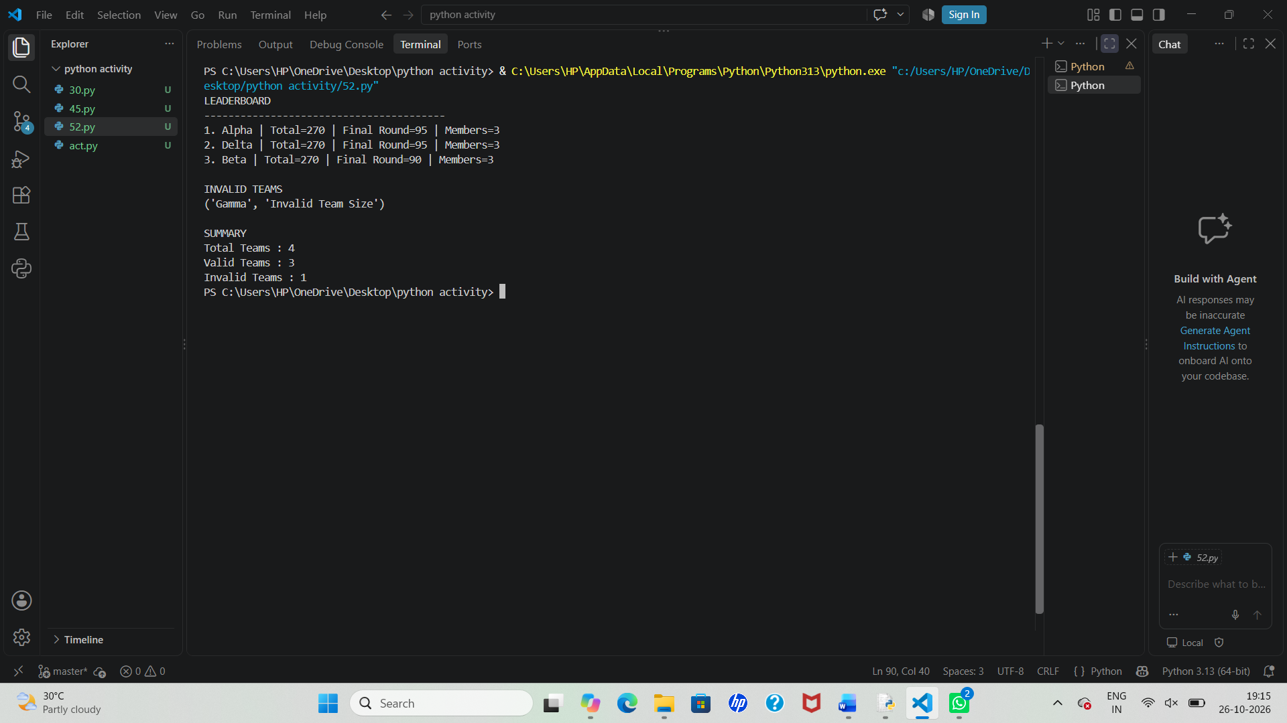
Pattern Generation
Display rank stars:
Python Program
for i in range(1, 6):
print("*" * i)
Output:
Plain Text
*
**
***
****
*****
84. Environmental Monitoring Data Analyzer: Analyse nested lists of air-quality or water-quality readings, calculate averages and extremes, and classify observations using supplied threshold values.
Problem Statement
Analyze environmental readings (Air Quality Index or Water Quality readings) stored in nested lists, calculate:
- Average reading
- Maximum and Minimum values
- Classification based on threshold values
- Overall environmental status
Computational Thinking
1. Decomposition
Break the problem into smaller tasks:
- Store environmental readings
- Calculate averages
- Find highest and lowest values
- Compare readings with thresholds
- Classify observations
- Generate summary report

2. Pattern Recognition
Each monitoring station records readings:
Plain Text
Station A → [45, 50, 55]
Station B → [80, 85, 90]
Station C → [35, 40, 42]
The same calculations apply to every station.

3. Abstraction
Represent readings using nested lists:
Plain Text
[
[45, 50, 55],
[80, 85, 90],
[35, 40, 42]
]

4. Algorithm Design
- Read station data.
- Calculate average for each station.
- Find minimum and maximum readings.
- Compare average with threshold values.
- Assign classification.
- Display results.

Algorithm
- Store station names and readings.
- Define thresholds:
  - Good: ≤ 50
  - Moderate: ≤ 100
  - Poor: > 100
- For each station:
  - Calculate average.
  - Find minimum and maximum.
  - Classify reading.
- Store results.
- Generate environmental report.

Flowchart
┌───────┐
│ Start │
└───┬───┘
│
▼
Input Readings
│
▼
Calculate Average
│
▼
Find Min and Max
│
▼
Compare Thresholds
│
▼
Assign Category
│
▼
More Stations?
Yes ───► Repeat
│
No
▼
Print Summary
│
▼
End
Psuedocode
BEGIN
FOR each station
average ← sum(readings)/count
maximum ← largest reading
minimum ← smallest reading
IF average <= 50
category ← "Good"
ELSE IF average <= 100
category ← "Moderate"
ELSE
category ← "Poor"
END FOR
Display Report
END
Variables and Data Types
Variable | Data Type | Purpose
stations | List | Station names
readings | Nested List | Environmental data
average | Float | Average reading
maximum | Integer | Highest reading
minimum | Integer | Lowest reading
category | String | Quality status
summary | Tuple | Final report

Python Program
# Monitoring Stations
stations = ["Station A", "Station B", "Station C"]
# Air Quality Readings
readings = [
[45, 50, 55, 48, 52],
[80, 85, 90, 82, 88],
[120, 125, 118, 122, 130]
]
report = []
highest_value = float('-inf')
lowest_value = float('inf')
print("ENVIRONMENTAL REPORT")
print("-" * 40)
for station, data in zip(stations, readings): # tuple unpacking
average = sum(data) / len(data)
maximum = max(data)
minimum = min(data)
highest_value = max(highest_value, maximum)
lowest_value = min(lowest_value, minimum)
# Classification
if average <= 50:
category = "Good"
elif average <= 100:
category = "Moderate"
else:
category = "Poor"
report.append(
(station, round(average, 2),
maximum, minimum, category)
)
print(f"\n{station}")
print("Average :", round(average, 2))
print("Maximum :", maximum)
print("Minimum :", minimum)
print("Status :", category)
# Create Summary Tuple
summary = (
highest_value,
lowest_value,
len(stations)
)
# Tuple Unpacking
highest, lowest, total_stations = summary
print("\nSUMMARY")
print("Highest Reading :", highest)
print("Lowest Reading :", lowest)
print("Stations Analyzed :", total_stations)
Sample Output
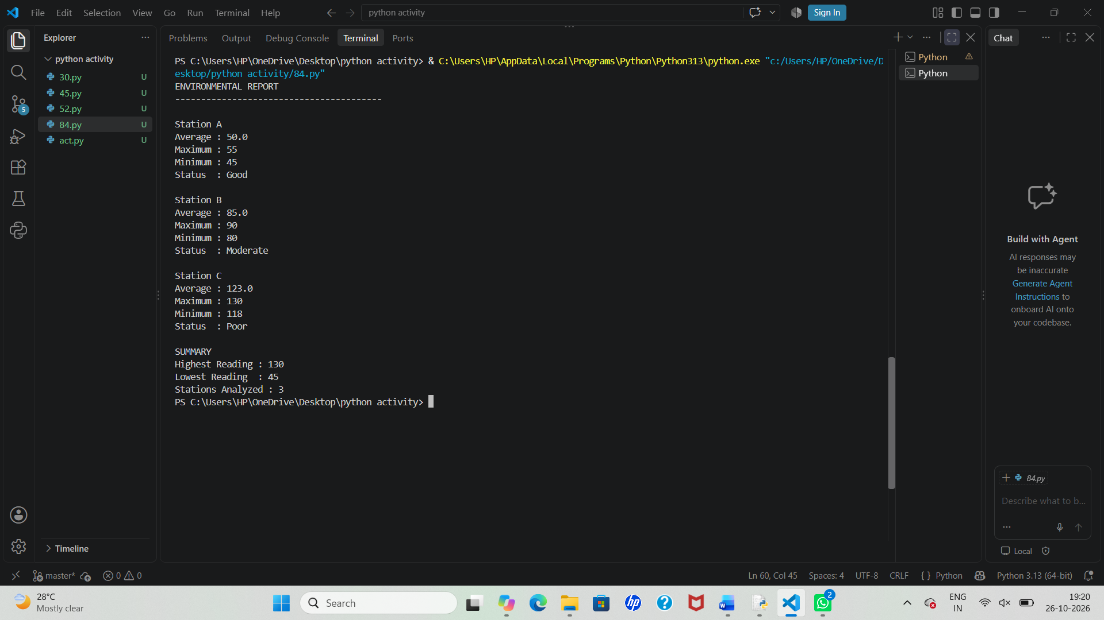
Pattern Generation
Environmental Alert Pattern:
Python
for i in range(1, 6):
print("🌿" * i)
Output:
Plain Text
🌿
🌿🌿
🌿🌿🌿
🌿🌿🌿🌿
🌿🌿🌿🌿🌿

Tuples and Tuple Operations
Python
record = ("Station A", 50.0, "Good")

print(record[0]) # Station Name
print(record[1]) # Average

station, avg, status = record # Unpacking

print(station, avg, status)
27. Advanced Numeric Pattern Generator: Produce a hollow diamond or symmetric numerical pattern based on user-specified dimensions, with validation for invalid dimensions and carefully aligned output.
Problem Statement
Create a program that generates a Hollow Diamond Pattern or Symmetric Number Pattern based on a user-specified dimension.
Requirements:
- Accept user input for size.
- Validate dimensions.
- Reject invalid sizes (negative, zero, even for diamond).
- Generate properly aligned output.
- Display patterns neatly.
1. Computational Thinking
Decomposition
Break the task into smaller parts:
- Read dimension.
- Validate input.
- Generate upper half.
- Generate lower half.
- Align output.
- Display pattern.

Pattern Recognition
For a hollow diamond of size 5:
Plain Text
1
2 2
3 3
4 4
5 5
4 4
3 3
2 2
1
Notice:
- Spaces decrease then increase.
- Numbers increase then decrease.
- Hollow center created using inner spaces.

Abstraction
Represent properties as:
Python
(size, row_number)
Example:
Python
(5, 3)

Algorithm Design
- Validate size.
- Generate upper pattern.
- Generate lower pattern.
- Print aligned rows.

Algorithm
Hollow Diamond
- Input odd integer n.
- If n ≤ 0:
  - Display error.
- Print upper half.
- Print lower half.
- End.

Flowchart
┌───────┐
│ Start │
└───┬───┘
│
▼
Input Size
│
▼
Valid Size?
┌───┴───┐
│ │
No Yes
│ │
▼ ▼
Error Generate
Pattern
│
▼
Display
│
▼
End
Pseudocode
BEGIN
INPUT n
IF n <= 0
PRINT "Invalid Size"
ELSE
FOR i = 1 TO n
PRINT upper diamond row
FOR i = n-1 TO 1
PRINT lower diamond row
END IF
END
Variables and Data Types
Variable | Data Type | Purpose
n | Integer | Pattern size
i | Integer | Row counter
spaces | String | Alignment
pattern | List | Store rows
row_info | Tuple | Row data

Python Program 1: Hollow Diamond Number Pattern
n = int(input("Enter size: "))
if n <= 0:
print("Invalid Dimension")
else:
pattern = []
# Upper Half
for i in range(1, n + 1):
left_space = " " * (n - i)
if i == 1:
row = left_space + str(i)
else:
middle_space = " " * (2 * i - 3)
row = left_space + str(i) + middle_space + str(i)
pattern.append(row)
# Lower Half
for i in range(n - 1, 0, -1):
left_space = " " * (n - i)
if i == 1:
row = left_space + str(i)
else:
middle_space = " " * (2 * i - 3)
row = left_space + str(i) + middle_space + str(i)
pattern.append(row)
for row in pattern:
print(row)
Sample Output
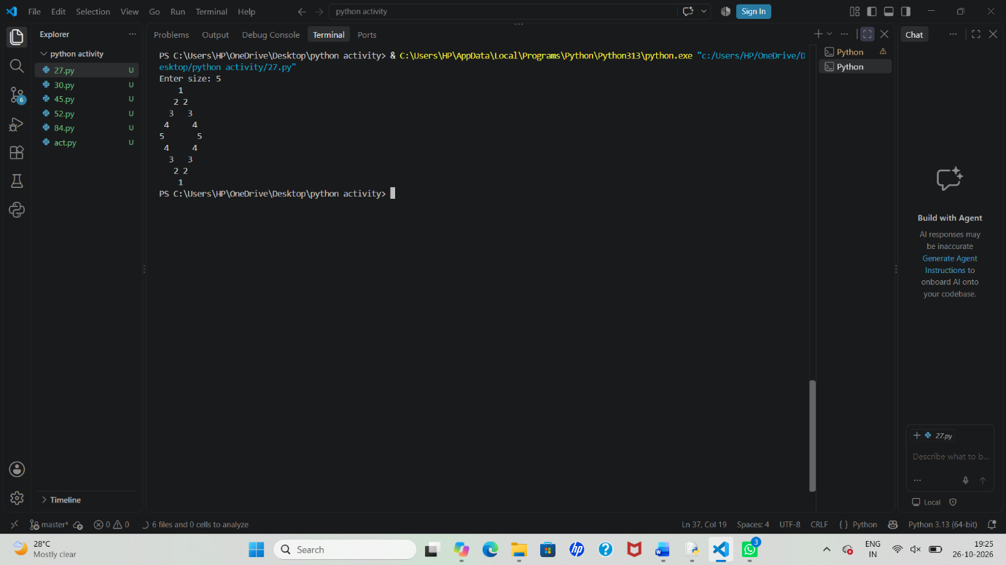
Python Program 2: Symmetric Palindrome Number Pattern
n = int(input("Enter size: "))
if n <= 0:
print("Invalid Dimension")
else:
for i in range(1, n + 1):
print(" " * (n - i), end="")
for j in range(i, 0, -1):
print(j, end="")
for j in range(2, i + 1):
print(j, end="")
print()
Sample Output
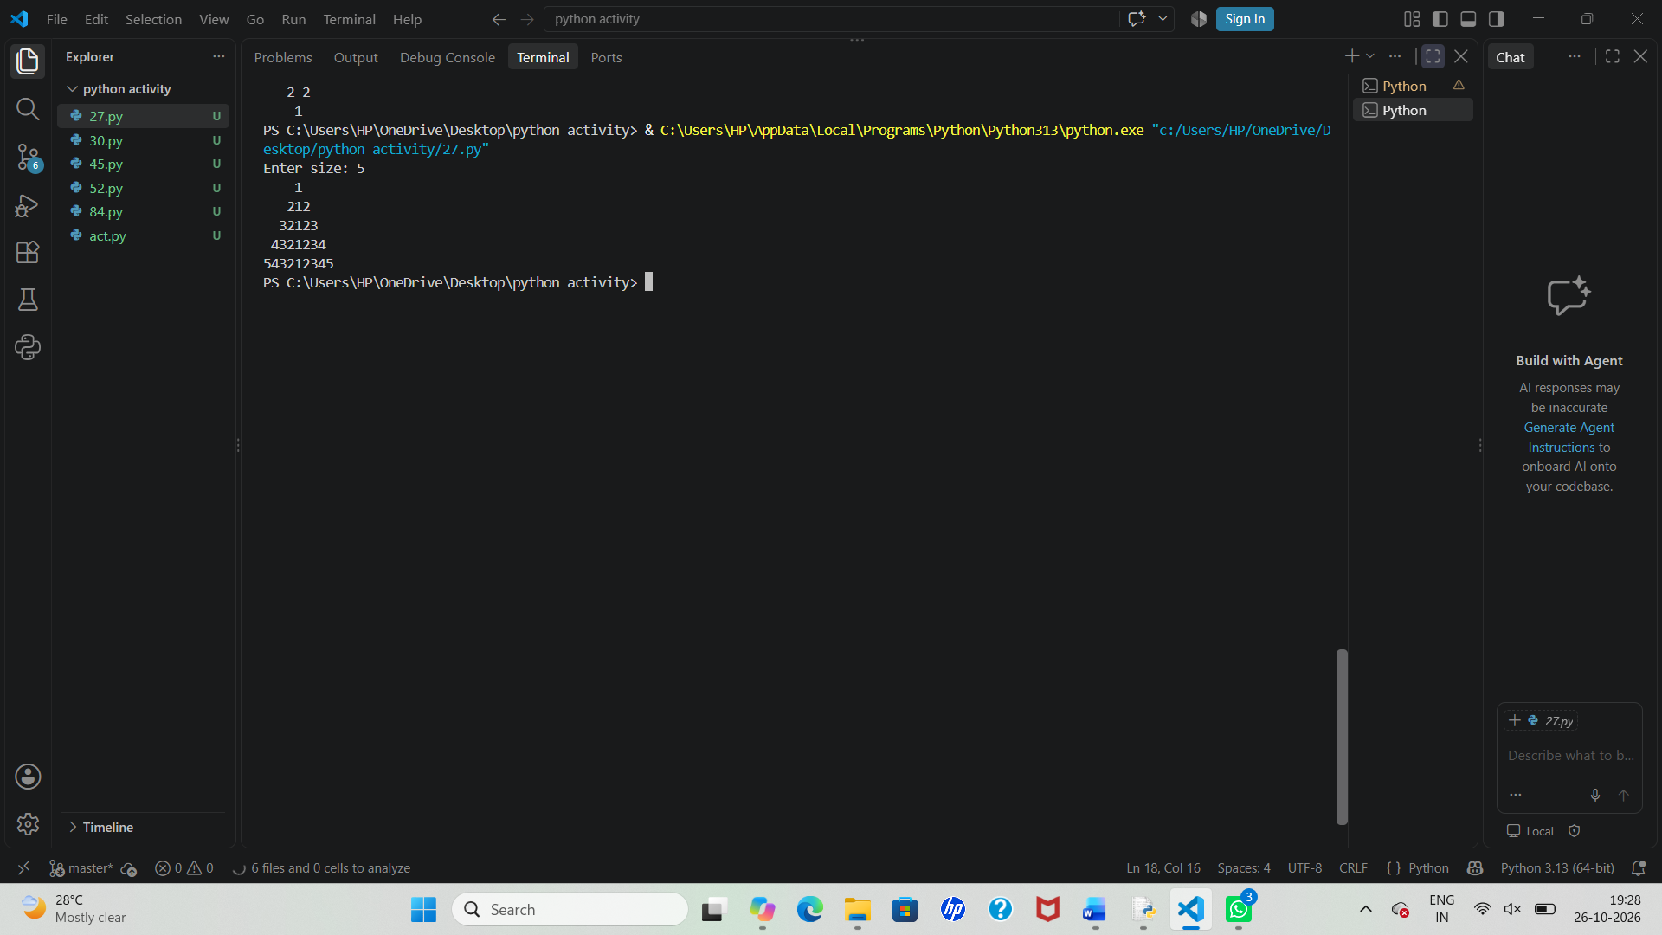
Lists, Nested Lists, Tuples and Unpacking
Using Nested Lists
Python
pattern_data = [
[1, "Row1"],
[2, "Row2"],
[3, "Row3"]
]
Tuple Example
Python
row_info = (3, "Middle Row")
Tuple Operations
Python
print(row_info[0])
print(row_info[1])
Tuple Unpacking
Python
row_no, description = row_info

print(row_no)
print(description)

Enhanced Validation
Python
n = int(input("Enter odd size: "))

if n <= 0:
print("Size must be positive")

elif n % 2 == 0:
print("Only odd dimensions allowed")

else:
print("Valid Size")
80. Multi-Day Bus Route Performance Analysis: Analyse passenger demand, journey times, fuel usage, and bus capacities; identify overloaded routes and compare operating efficiency using supplied criteria.
Problem Statement
Analyze bus-route performance over multiple days using:
- Passenger demand
- Journey times
- Fuel consumption
- Bus capacities
Computational Thinking
1. Decomposition
Break the problem into smaller tasks:
- Store route data.
- Calculate passenger totals.
- Calculate average journey times.
- Calculate fuel usage.
- Check bus capacities.
- Identify overloaded routes.
- Compute operating efficiency.
- Rank routes.

2. Pattern Recognition
Each route contains:
Plain Text
Route Name
Capacity
Passengers
Journey Time
Fuel Used
Example:
Plain Text
Route A
Capacity = 50

Day-wise:
Passengers = [45, 52, 48]
Time = [60, 65, 58]
Fuel = [10, 11, 9]

3. Abstraction
Represent each route using a tuple:
Plain Text
("Route A", 50,
[45,52,48],
[60,65,58],
[10,11,9])

4. Algorithm Design
For each route:
- Calculate total passengers.
- Calculate average journey time.
- Calculate total fuel.
- Determine overload status.
- Compute efficiency:
Plain Text
Efficiency =
Total Passengers ÷ Total Fuel
Higher efficiency = Better route.

Algorithm
- Read route data.
- For each route:
  - Compute passenger total.
  - Compute average journey time.
  - Compute fuel total.
  - Check overload conditions.
  - Calculate efficiency.
- Store results.
- Compare efficiencies.
- Display performance report.

Flowchart
┌───────┐
│ Start │
└───┬───┘
│
▼
Read Route Data
│
▼
Calculate Totals
│
▼
Check Capacity
│
▼
Compute Efficiency
│
▼
Store Results
│
▼
More Routes?
Yes ───► Repeat
│
No
▼
Rank Routes
│
▼
Display Report
│
▼
End
Psuedocode
BEGIN
FOR each route
total_passengers ← SUM(passengers)
avg_time ← SUM(times)/days
total_fuel ← SUM(fuel)
efficiency ←
total_passengers / total_fuel
FOR each passenger count
IF passengers > capacity
Mark overloaded
END FOR
END FOR
Find highest efficiency route
Display report
END
Variables and Data Types
Variable | Data Type | Purpose
route_name | String | Route name
capacity | Integer | Bus capacity
passengers | List | Daily passenger counts
journey_times | List | Daily travel times
fuel | List | Daily fuel usage
efficiency | Float | Operating efficiency
report | List | Performance records
summary | Tuple | Report summary
Python Program
# Route Data
routes = [
("Route A", 50,
[45, 52, 48, 55, 50],
[60, 65, 58, 62, 61],
[10, 11, 9, 12, 10]),
("Route B", 40,
[35, 39, 42, 38, 36],
[55, 57, 56, 54, 58],
[8, 8, 9, 7, 8]),
("Route C", 60,
[58, 62, 65, 61, 59],
[70, 68, 72, 69, 71],
[15, 14, 16, 15, 14])
]
report = []
best_route = ""
best_efficiency = 0
print("BUS ROUTE PERFORMANCE REPORT")
print("-" * 50)
for route_name, capacity, passengers, times, fuel in routes:
total_passengers = sum(passengers)
avg_time = sum(times) / len(times)
total_fuel = sum(fuel)
efficiency = total_passengers / total_fuel
overloaded_days = 0
for count in passengers:
if count > capacity:
overloaded_days += 1
report.append(
(
route_name,
total_passengers,
round(avg_time, 2),
total_fuel,
round(efficiency, 2),
overloaded_days
)
)
if efficiency > best_efficiency:
best_efficiency = efficiency
best_route = route_name
# Display Report
for route in report:
(
name,
passengers_total,
avg_journey,
fuel_total,
efficiency,
overloads
) = route
print("\nRoute :", name)
print("Passengers :", passengers_total)
print("Average Time :", avg_journey)
print("Fuel Used :", fuel_total)
print("Efficiency :", efficiency)
if overloads > 0:
print("Overloaded Days :", overloads)
else:
print("No Overloads")
# Summary Tuple
summary = (
best_route,
round(best_efficiency, 2),
len(routes)
)
# Tuple Unpacking
route, efficiency, total_routes = summary
print("\nSUMMARY")
print("Best Route :", route)
print("Best Efficiency :", efficiency)
print("Routes Analysed :", total_routes)
Sample Output
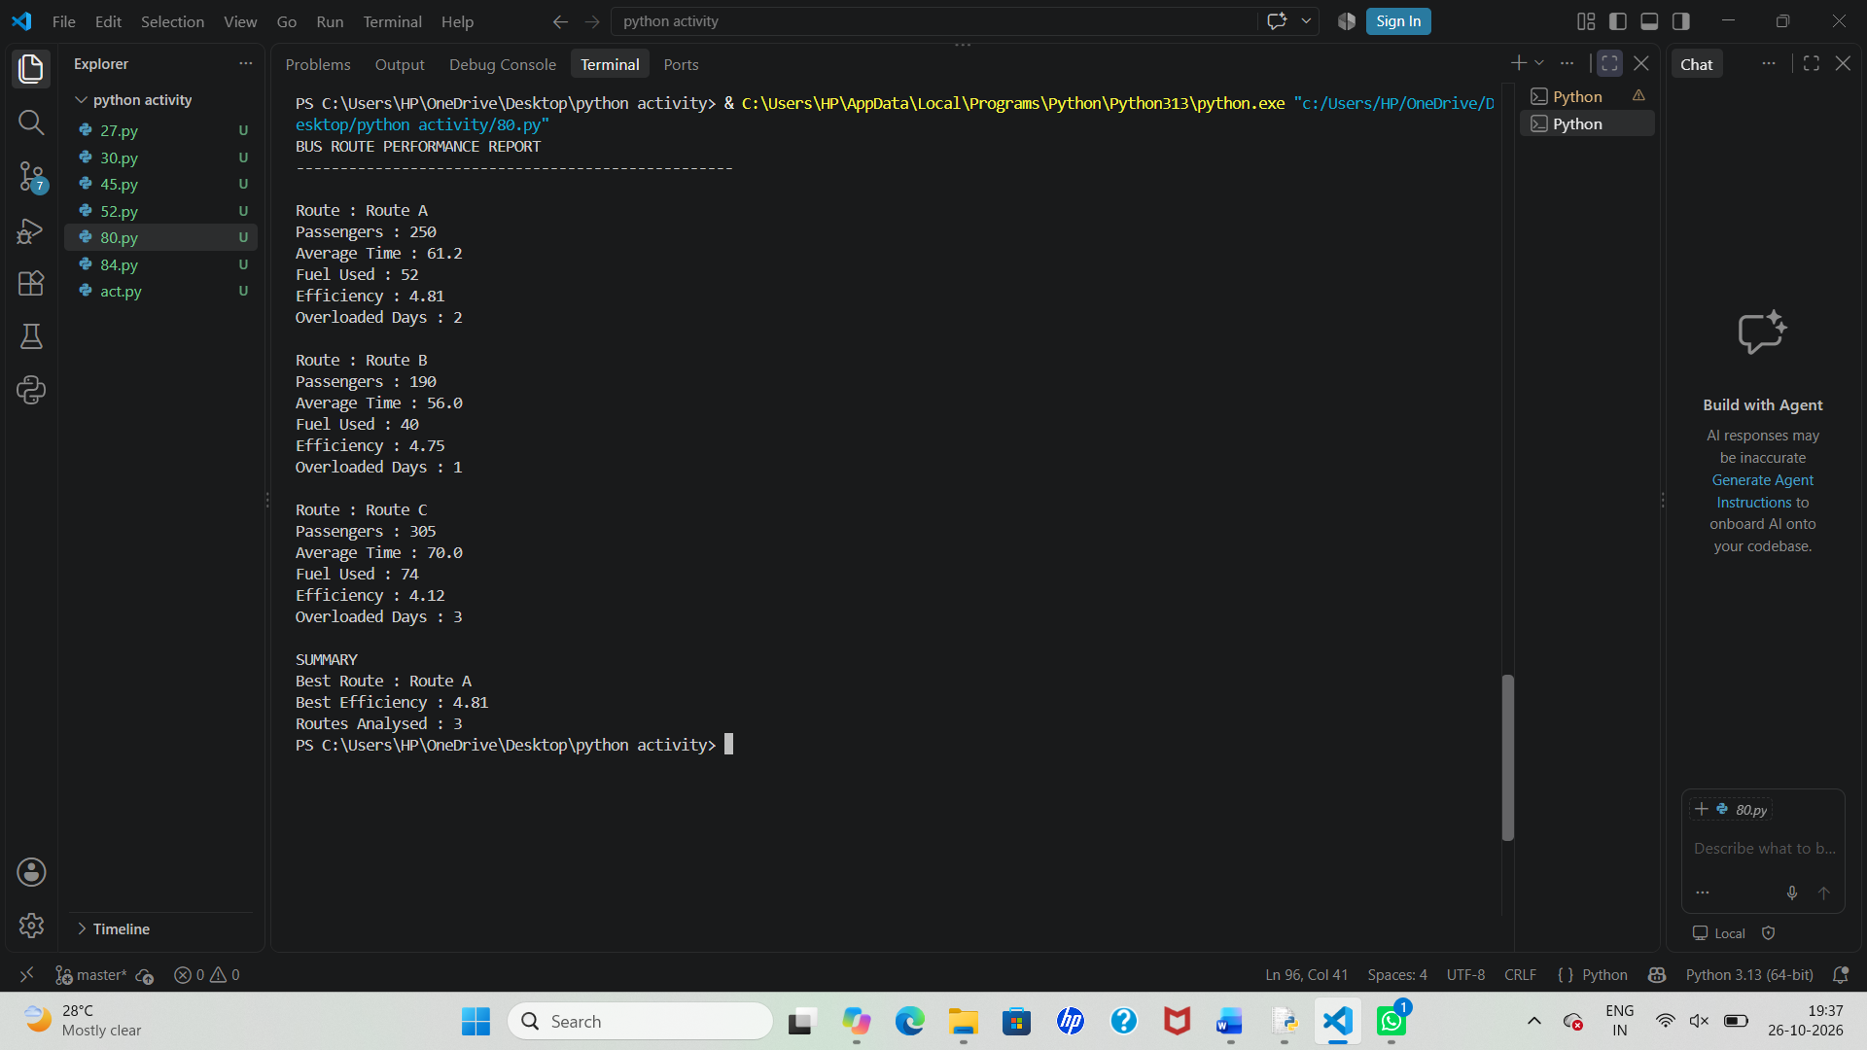
Pattern Generation
Display route performance stars:
Python
for i in range(1, 6):
print("*" * i)
Output:
Plain Text
*
**
***
****
*****

Tuples and Tuple Unpacking
Python
route_record = (
"Route A",
250,
4.81
)

name, passengers, efficiency = route_record

print(name)
print(passengers)
print(efficiency)
85. Smart Classroom Timetable Allocation: Represent courses, rooms, and periods using lists and tuples; validate classroom capacities, detect clashes, and check whether all courses can be accommodated under the stated constraints.
Problem Statement
Design a system that allocates courses to classrooms and time periods while:
- Validating classroom capacities
- Detecting timetable clashes
- Checking room availability
- Ensuring all courses are accommodated
- Generating an allocation report
Computational Thinking
1. Decomposition
Break the problem into smaller tasks:
- Store courses.
- Store classroom details.
- Store timetable allocations.
- Check classroom capacity.
- Detect room clashes.
- Verify all courses are scheduled.
- Generate final report.

2. Pattern Recognition
Each course requires:
Plain Text
Course Name
Students Enrolled
Assigned Room
Assigned Period
Example:
Plain Text
Python Programming
40 Students
Room A101
Period 1
Each room has:
Plain Text
Room Name
Capacity

3. Abstraction
Represent courses and classrooms using tuples:
Plain Text
("Python", 40)
("Data Science", 60)
Plain Text
("A101", 50)
("B201", 80)
Allocation:
Plain Text
("Python", "A101", "P1")

4. Algorithm Design
For every allocation:
- Verify room exists.
- Check capacity.
- Check room-period clashes.
- Store valid schedules.
- Generate summary.

Algorithm
- Store courses.
- Store classrooms.
- Store timetable allocations.
- For each allocation:
  - Verify room.
  - Compare students with room capacity.
  - Check duplicate room-period usage.
- Mark clashes/errors.
- Check whether all courses are allocated.
- Display report.

Flowchart
┌───────┐
│ Start │
└───┬───┘
│
▼
Input Course Data
│
▼
Read Allocations
│
▼
Check Capacity
│
▼
Room Clash?
┌───┴───┐
│ │
Yes No
│ │
▼ ▼
Report Store
Error Allocation
│
▼
More Records?
Yes ───► Repeat
│
No
▼
All Courses Assigned?
│
▼
Generate Report
│
▼
End
Pseudocode
BEGIN
FOR each allocation
Check room capacity
IF students > capacity
Report capacity violation
Check room-period combination
IF duplicate exists
Report clash
END FOR
Check all courses assigned
Display report
END
Variables and Data Types
Variable | Data Type | Purpose
courses | List | Course details
rooms | Dictionary | Room capacities
allocations | List | Timetable entries
clashes | List | Clash reports
room_capacity | Integer | Capacity
students | Integer | Enrolled students
summary | Tuple | Report summary

Python Program
# Courses (Course, Students)
courses = [
("Python", 40),
("Data Science", 70),
("AI", 35),
("Cyber Security", 50)
]
# Rooms and Capacities
rooms = {
"A101": 50,
"B201": 80,
"C301": 40
}
# Timetable Allocation
# (Course, Room, Period)
allocations = [
("Python", "A101", "P1"),
("Data Science", "B201", "P1"),
("AI", "C301", "P1"),
("Cyber Security", "A101", "P1")
]
clashes = []
capacity_errors = []
scheduled_courses = []
used_slots = []
print("SMART CLASSROOM TIMETABLE REPORT")
print("-" * 45)
for course_name, room, period in allocations:
scheduled_courses.append(course_name)
# Find student count
students = 0
for course, count in courses:
if course == course_name:
students = count
break
# Capacity Validation
if students > rooms[room]:
capacity_errors.append(
(course_name, room, students, rooms[room])
)
# Clash Detection
slot = (room, period)
if slot in used_slots:
clashes.append(
(course_name, room, period)
)
else:
used_slots.append(slot)
# Capacity Report
print("\nCAPACITY CHECK")
if capacity_errors:
for course, room, students, capacity in capacity_errors:
print(
f"{course} exceeds capacity "
f"({students}/{capacity})"
)
else:
print("No Capacity Issues")
# Clash Report
print("\nCLASH CHECK")
if clashes:
for course, room, period in clashes:
print(
f"Clash: {course} "
f"in {room} during {period}"
)
else:
print("No Clashes")
# Unscheduled Courses
unscheduled = []
for course, count in courses:
if course not in scheduled_courses:
unscheduled.append(course)
print("\nUNSCHEDULED COURSES")
if unscheduled:
for c in unscheduled:
print(c)
else:
print("All Courses Scheduled")
# Summary Tuple
summary = (
len(courses),
len(clashes),
len(capacity_errors)
)
# Tuple Unpacking
total_courses, clash_count, error_count = summary
print("\nSUMMARY")
print("Total Courses :", total_courses)
print("Clashes Found :", clash_count)
print("Capacity Errors :", error_count)

Sample Output
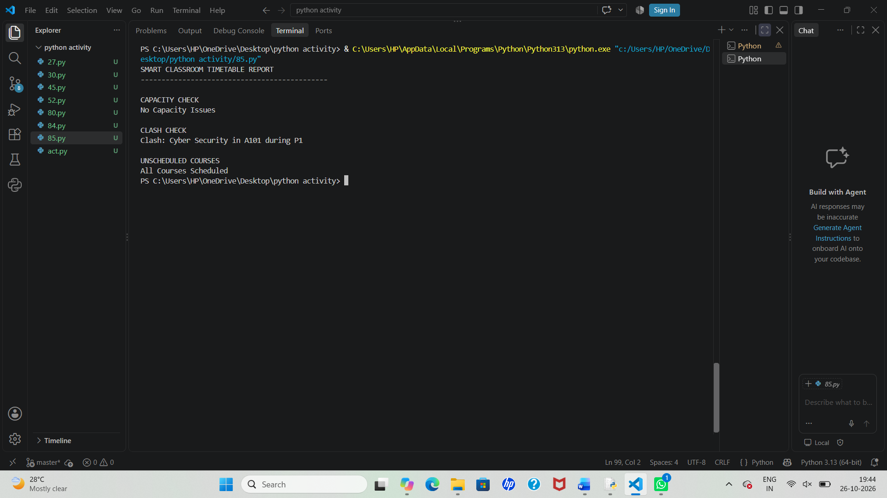
Pattern Generation
Display classroom utilization pattern:
Python
for i in range(1, 6):
print("#" * i)
Output
Plain Text
#
##
###
####
#####

Lists and Nested Lists
List Example
Python
periods = ["P1", "P2", "P3", "P4"]
Nested List Example
Python
weekly_schedule = [
["Python", "AI"],
["Data Science", "Cyber Security"]
]

Tuples and Unpacking
Tuple
Python
record = ("Python", "A101", "P1")
Access Elements
Python
print(record[0])
print(record[1])
print(record[2])
Tuple Unpacking
Python
course, room, period = record

print(course)
print(room)
print(period)
42. Student Marks Matrix Analysis: Analyse a matrix of student marks across subjects, calculate row-wise and column-wise statistics, identify top performers, and detect subjects with low average performance.
Problem Statement
Analyze a matrix of student marks across multiple subjects and:
- Calculate row-wise statistics (student totals and averages)
- Calculate column-wise statistics (subject averages)
- Identify top performers
- Detect subjects with low average performance
- Generate a performance report
Computational Thinking
1. Decomposition
Break the problem into smaller tasks:
- Store student marks.
- Calculate student totals.
- Calculate student averages.
- Calculate subject averages.
- Identify top performer.
- Detect low-performing subjects.
- Generate summary report.

2. Pattern Recognition
Marks are arranged in a matrix:
Plain Text
Math Science English
Student 1 85 90 78
Student 2 92 88 95
Student 3 70 75 80
Rows represent students.
Columns represent subjects.

3. Abstraction
Represent marks using a nested list:
Python
[
[85,90,78],
[92,88,95],
[70,75,80]
]

4. Algorithm Design
For each student:
- Calculate total marks.
- Calculate average marks.
For each subject:
- Calculate average marks.
- Compare with threshold.
Find:
- Highest total scorer.
- Subjects below specified average.

Algorithm
- Store student names and marks matrix.
- Calculate row-wise totals and averages.
- Find highest-scoring student.
- Calculate column-wise averages.
- Compare subject averages with threshold.
- Display report.

Flowchart
┌───────┐
│ Start │
└───┬───┘
│
▼
Input Marks Matrix
│
▼
Calculate Student Totals
│
▼
Find Top Performer
│
▼
Calculate Subject Averages
│
▼
Compare Threshold
│
▼
Generate Report
│
▼
End
Pseudocode
BEGIN
FOR each student
total ← sum(marks)
average ← total / subjects
IF total > highest_total
update topper
END FOR
FOR each subject column
subject_average ← sum(column)
/ total_students
IF subject_average < threshold
mark low-performing
END FOR
Display Report
END
Variables and Data Types
Variable | Data Type | Purpose
students | List | Student names
subjects | List | Subject names
marks | Nested List | Marks matrix
total | Integer | Student total
average | Float | Student average
topper | String | Highest scorer
low_subjects | List | Weak subjects
summary | Tuple | Final report

Python Program
# Student Names
students = ["Rahul", "Priya", "Arun", "Sneha"]
# Subject Names
subjects = ["Math", "Science", "English"]
# Marks Matrix
marks = [
[85, 90, 78],
[92, 88, 95],
[70, 75, 80],
[95, 91, 89]
]
threshold = 80
student_report = []
topper = ""
highest_total = 0
print("STUDENT PERFORMANCE REPORT")
print("-" * 40)
# Row-wise Analysis
for student, score_list in zip(students, marks):
total = sum(score_list)
average = total / len(score_list)
student_report.append(
(student, total, round(average, 2))
)
print(
student,
"Total =", total,
"Average =", round(average, 2)
)
if total > highest_total:
highest_total = total
topper = student
# Column-wise Analysis
subject_averages = []
low_subjects = []
print("\nSUBJECT ANALYSIS")
for col in range(len(subjects)):
total = 0
for row in range(len(students)):
total += marks[row][col]
avg = total / len(students)
subject_averages.append(avg)
print(
subjects[col],
"Average =",
round(avg, 2)
)
if avg < threshold:
low_subjects.append(subjects[col])
# Summary Tuple
summary = (
topper,
highest_total,
len(low_subjects)
)
# Tuple Unpacking
top_student, top_score, low_count = summary
print("\nTOP PERFORMER")
print(top_student, "-", top_score)
print("\nLOW PERFORMING SUBJECTS")
if low_subjects:
for subject in low_subjects:
print(subject)
else:
print("None")
print("\nSUMMARY")
print("Top Student:", top_student)
print("Highest Score:", top_score)
print("Low Subjects:", low_count)
Sample Output
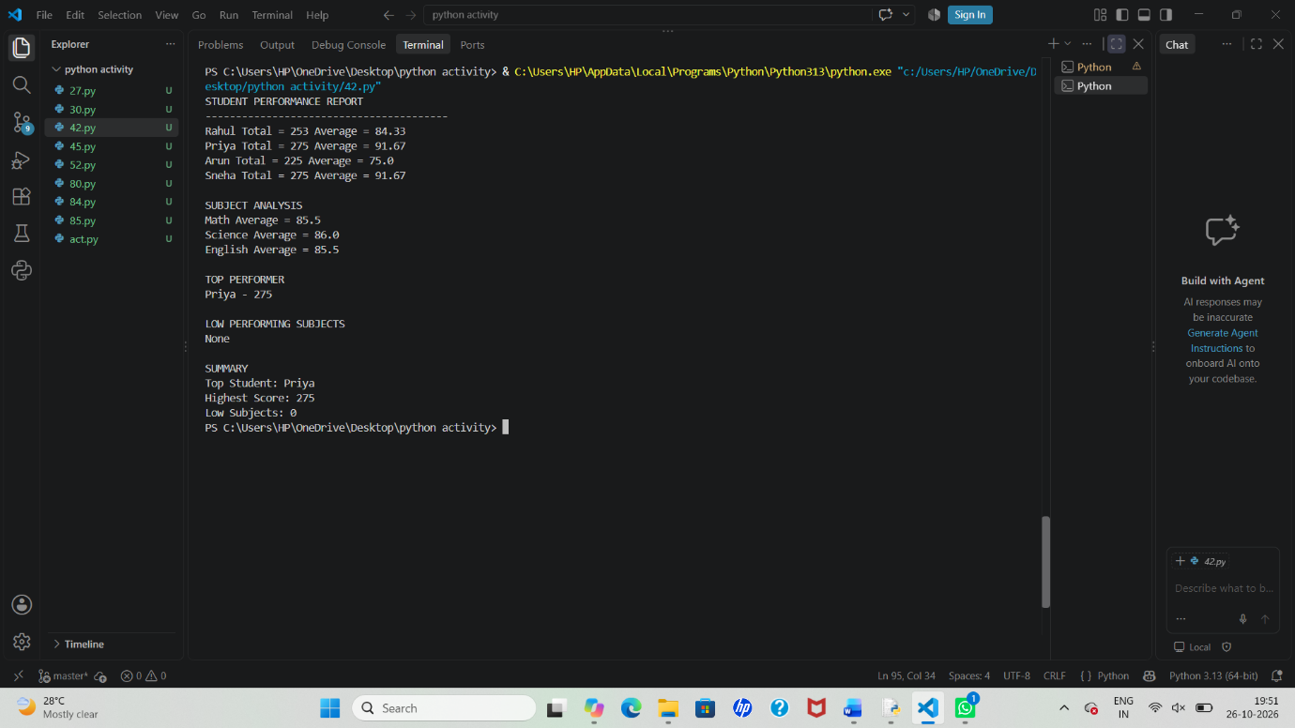
Pattern Generation
Display performance stars:
Python
for i in range(1, 6):
print("*" * i)
Output
Plain Text
*
**
***
****
*****

Nested Lists Example
Python
marks = [
[85, 90, 78],
[92, 88, 95],
[70, 75, 80]
]
- Rows → Students
- Columns → Subjects

Tuples and Tuple Unpacking
Tuple Creation
Python
record = ("Priya", 275, 91.67)
Tuple Operations
Python
print(record[0])
print(record[1])
Tuple Unpacking
Python
name, total, average = record

print(name)
print(total)
print(average)

